DAY-2

1. write a c program sum of elements in a array.

Program:

#include<stdio.h>

#include<string.h>

int main()

{

int a[1000],i,n,sum=0;

printf("Enter size of the array : ");

scanf("%d",&n);

printf("Enter elements in array : ");

for(i=0; i<n; i++)

{

scanf("%d",&a[i]);

}

for(i=0; i<n; i++)

{

sum+=a[i];

}

printf("sum of array is : %d",sum);

return 0;

}

Output:

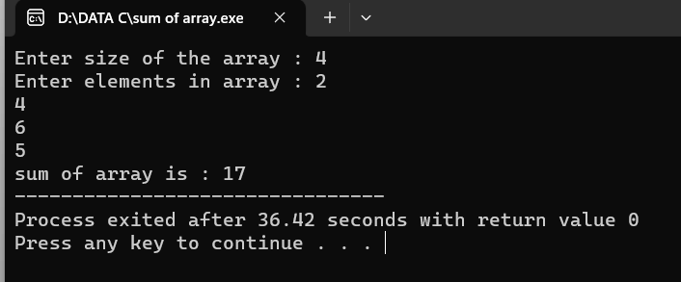

1. write a c program to merge two arrays

Program:

#include<stdio.h>

#include<conio.h>

int main()

{

int arr1[50], arr2[50], size1, size2, i, k, merge[100];

printf("Enter Array 1 Size: ");

scanf("%d", &size1);

printf("Enter Array 1 Elements: ");

for(i=0; i<size1; i++)

{

scanf("%d", &arr1[i]);

merge[i] = arr1[i];

}

k = i;

printf("\nEnter Array 2 Size: ");

scanf("%d", &size2);

printf("Enter Array 2 Elements: ");

for(i=0; i<size2; i++)

{

scanf("%d", &arr2[i]);

merge[k] = arr2[i];

k++;

}

printf("\nThe new array after merging is:\n");

for(i=0; i<k; i++)

printf("%d ", merge[i]);

getch();

return 0;

}

Output:

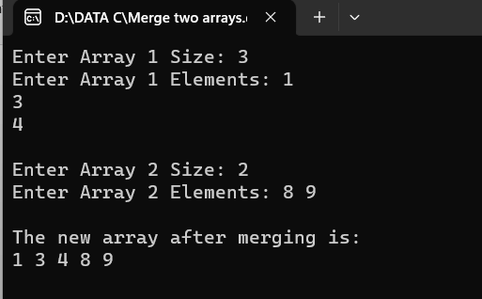

1. write a c program to perform insertion and deletion from the middle in the array.

Program:

#include <stdio.h>

#include <conio.h>

int main ()

{

int arr[50];

int pos, i, num;

printf (" \n Enter the number of elements in an array: \n ");

scanf (" %d", &num);

printf (" \n Enter %d elements in array: \n ", num);

for (i = 0; i < num; i++ )

{ printf (" arr[%d] = ", i);

scanf (" %d", &arr[i]);

}

printf( " Delete the element : \n ");

scanf (" %d", &pos);

if (pos >= num+1)

{

printf (" \n Delete is not possible.");

}

else

{

for (i = pos - 1; i < num -1; i++)

{

arr[i] = arr[i+1];

}

printf (" \n The resultant array is: \n");

for (i = 0; i< num - 1; i++)

{

printf (" arr[%d] = ", i);

printf (" %d \n", arr[i]);

}

}

return 0;

}

Output: 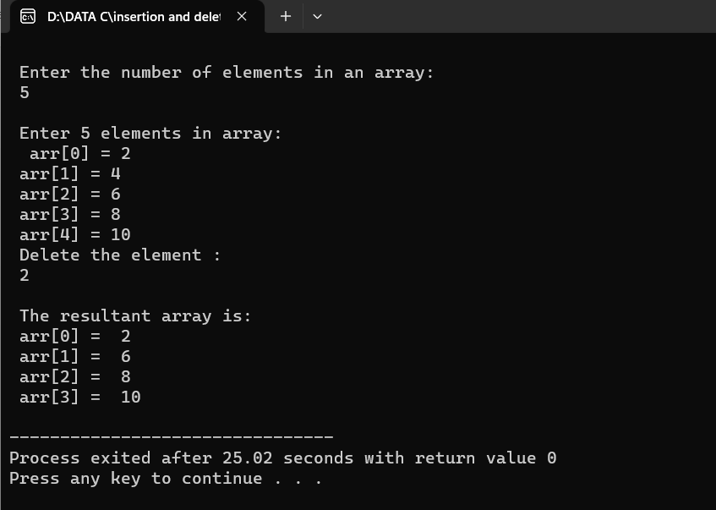

1. write a c program to reverse a string

Program:

#include<stdio.h>

int main()

{

int i,n;

char str[50];

printf("enter a string\n");

gets(str);

n=strlen(str);

printf("\nreverse string\n");

for(i=n-1;i>=0;i--)

{

printf("%c",str[i]);

}

}

Output:

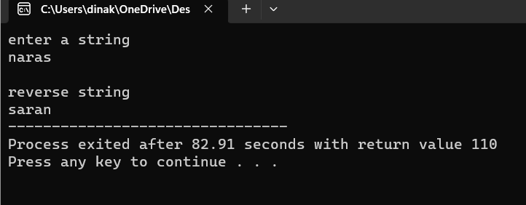

1. write a c program to check given string is pallindrome or not

Program:

#include <stdio.h>

#include <string.h>

int checkpalindrome(char \*s)

{

int i,c=0,n;

n=strlen(s);

for(i=0;i<n/2;i++)

{

if(s[i]==s[n-i-1])

c++;}

if(c==i)

return 1;

else

return 0;}

int main()

{char s[1000];

printf("Enter the string: ");

gets(s);

if(checkpalindrome(s))

printf("string is palindrome");

else

printf("string is not palindrome");

}

Output: 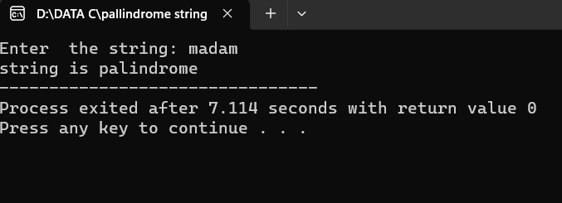

1. write a c program to search particular character in a string(if the character found return to be index)

Program:

#include <stdio.h>

int main()

{

char str[30],ch;

int ind[10],loop,j;

printf("Enter string: ");

scanf("%[^\n]s",str);

printf("Enter character: ");

getchar();

ch=getchar();

j=0;

for(loop=0; str[loop]!='\0'; loop++)

{

if(str[loop]==ch)

ind[j++]=loop;

}

printf("Input string is: %s\n",str);

printf("Indexes: ");

for(loop=0; loop<j; loop++)

printf("%d \t",ind[loop]);

return 0; }

Output: 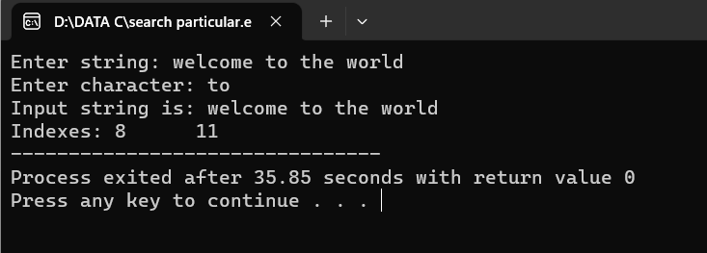

1. write a c program to count no of times present in the given string

Program:

#include <stdio.h>

#include <string.h>

int main()

{ char str[100];

int vowels = 0;

printf("Enter a string: ");

fgets(str, 100, stdin);

for(int i = 0; i < strlen(str); i++)

{

if(str[i] == 'a' || str[i] == 'e' || str[i] == 'i' || str[i] == 'o' || str[i] == 'u' || str[i] == 'A' || str[i] == 'E' || str[i] == 'I' || str[i] == 'O' || str[i] == 'U')

{

vowels++;

}

}

printf("Number of vowels: %d", vowels);

return 0;

}

Output:

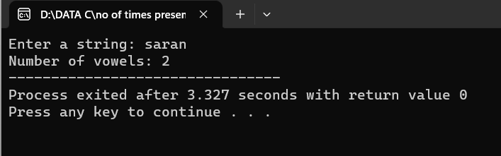

1. write a c program to perfom matrix multiplication

Program:

#include<stdio.h>

#include<stdlib.h>

int main(){

int a[10][10],b[10][10],mul[10][10],r,c,i,j,k;

system("cls");

printf("enter the number of row=");

scanf("%d",&r);

printf("enter the number of column=");

scanf("%d",&c);

printf("enter the first matrix element=\n");

for(i=0;i<r;i++)

{ for(j=0;j<c;j++)

{ scanf("%d",&a[i][j]); }

} printf("enter the second matrix element=\n");

for(i=0;i<r;i++) {

for(j=0;j<c;j++) {

scanf("%d",&b[i][j]);

}

} printf("multiply of the matrix=\n");

for(i=0;i<r;i++) {

for(j=0;j<c;j++) {

mul[i][j]=0;

for(k=0;k<c;k++)

{ mul[i][j]+=a[i][k]\*b[k][j];}}}

for(i=0;i<r;i++){

for(j=0;j<c;j++){

printf("%d\t",mul[i][j]);}

printf("\n");}

return 0;

}

Output:

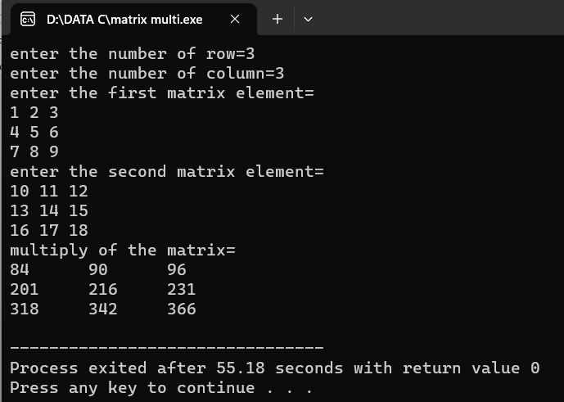

1. write a c program to perform all string manipulation

Program:

#include <stdio.h>

int main(void)

{

char str[] = "SARAN";

int i;

i = 0;

while(str[i] != '\0') {

printf("%c\n", str[i]);

i++;

}

printf("End of code\n");

return 0;

}

Output:

